The Last Supper on the Moon
“One for the Road”
Duane Eger, Impact Elder November 27, 2022

[Opening video – series trailer]

[Blank]

[Christmas at the Movies Slide]

[Blank]

[Picture of Apollo XI and Artemis I rockets]

[Blank]

[Show amateur video of rocket launch from beach]

[Blank]

A process of change or development that leads toward a particular result.

[Blank]

We must guard the integrity of our trajectory.

[Blank]

[Show Stearman airplane picture]

[Blank]

“If you love me, keep my commands.” John 14:15 (New International Version)

[Blank]

[Show first IF-THEN slide]
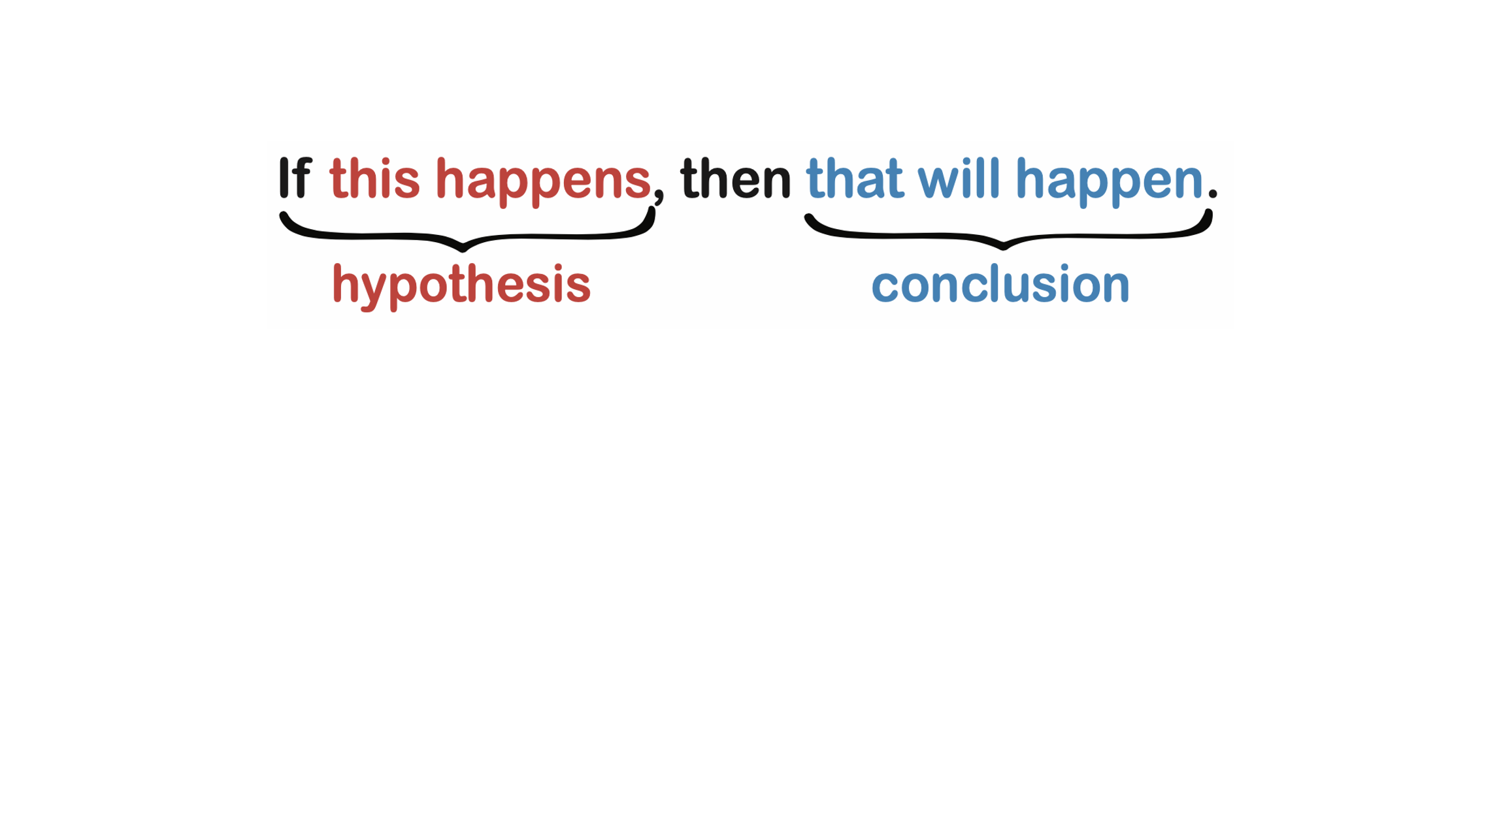

[Show second IF-THEN slide]
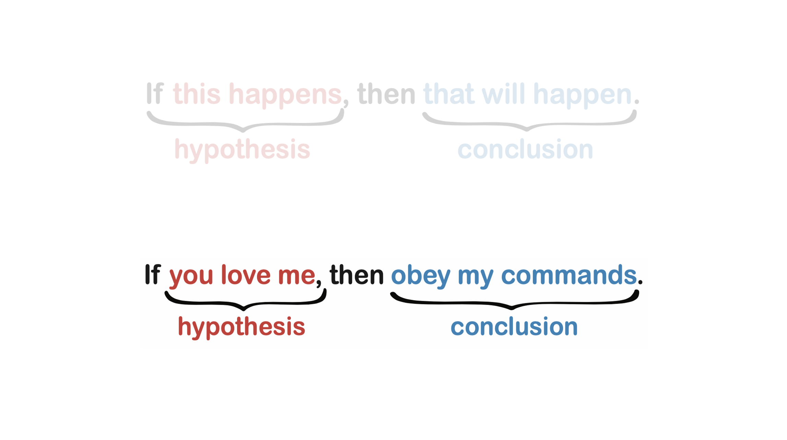

[Blank]

If you love me, keep my commands. And I will ask the Father, and he will give you another advocate to help you and be with you forever.” John 14:15-16 (New International Version)

[Blank]

“the Spirit of truth. The world cannot accept him, because it neither sees him nor knows him. But you know him, for he lives with you and will be in you. I will not leave you as orphans; I will come to you.“ John 14:17-18 (New International Version)

[Blank]

Without guidance, trajectory is nothing more than an aimless path to destruction.

[Blank]

[Play Go-No go audio clip]
[Blank]

“…My God, my God, why have You forsaken Me?” Matthew 27:46 (New International Version)

[Blank]

“When they hurled their insults at him, he did not retaliate; when he suffered, he made no threats. Instead, he entrusted himself to him who judges justly. ‘He himself bore our sins’ in his body on the cross, so that we might die to sins and live for righteousness; ‘by his wounds you have been healed.’” I Peter 2:23-24 (New International Version)

[Blank]

“Now my soul is troubled, and what shall I say? ‘Father, save me from this hour’? No, it was for this very reason I came to this hour.” John 12:27 (New International Version)

[Blank]

“For what I received I passed on to you as of first importance: that Christ died for our sins according to the Scriptures, that he was buried, that he was raised on the third day according to the Scriptures.” I Corinthians 15: 3-4 (New International Version)

[Blank]

“But the Advocate, the Holy Spirit, whom the Father will send in my name, will teach you all things and will remind you of everything I have said to you.” John 14:26 (New International Version)

[Blank]

“Peace I leave with you; my peace I give you. I do not give to you as the world gives. Do not let your hearts be troubled and do not be afraid.” John 14:27 (New International Version)

[Blank]

