The Last Supper on the Moon
“When God Lets You Down”
Bill Balbach, Lead Pastor November 20, 2022

“Now a man named Lazarus was sick. He was from Bethany, the village of Mary and her sister Martha. (This Mary, whose brother Lazarus now lay sick, was the same one who poured perfume on the Lord and wiped his feet with her hair.)” John 11:1-2 (New International)

[Blank]

“Just as people are destined to die once, and after that to face judgment,” Hebrews 9:27 (New International)

[Blank]

“So the sisters sent word to Jesus, “Lord, the one you love is sick.”” John 11:3 (New International)

[Blank]

“When he heard this, Jesus said, “This sickness will not end in death. No, it is for God’s glory so that God’s Son may be glorified through it.”” John 11:4 (New International)

Don’t jump to conclusions.

[Pic of Earth from the Moon]
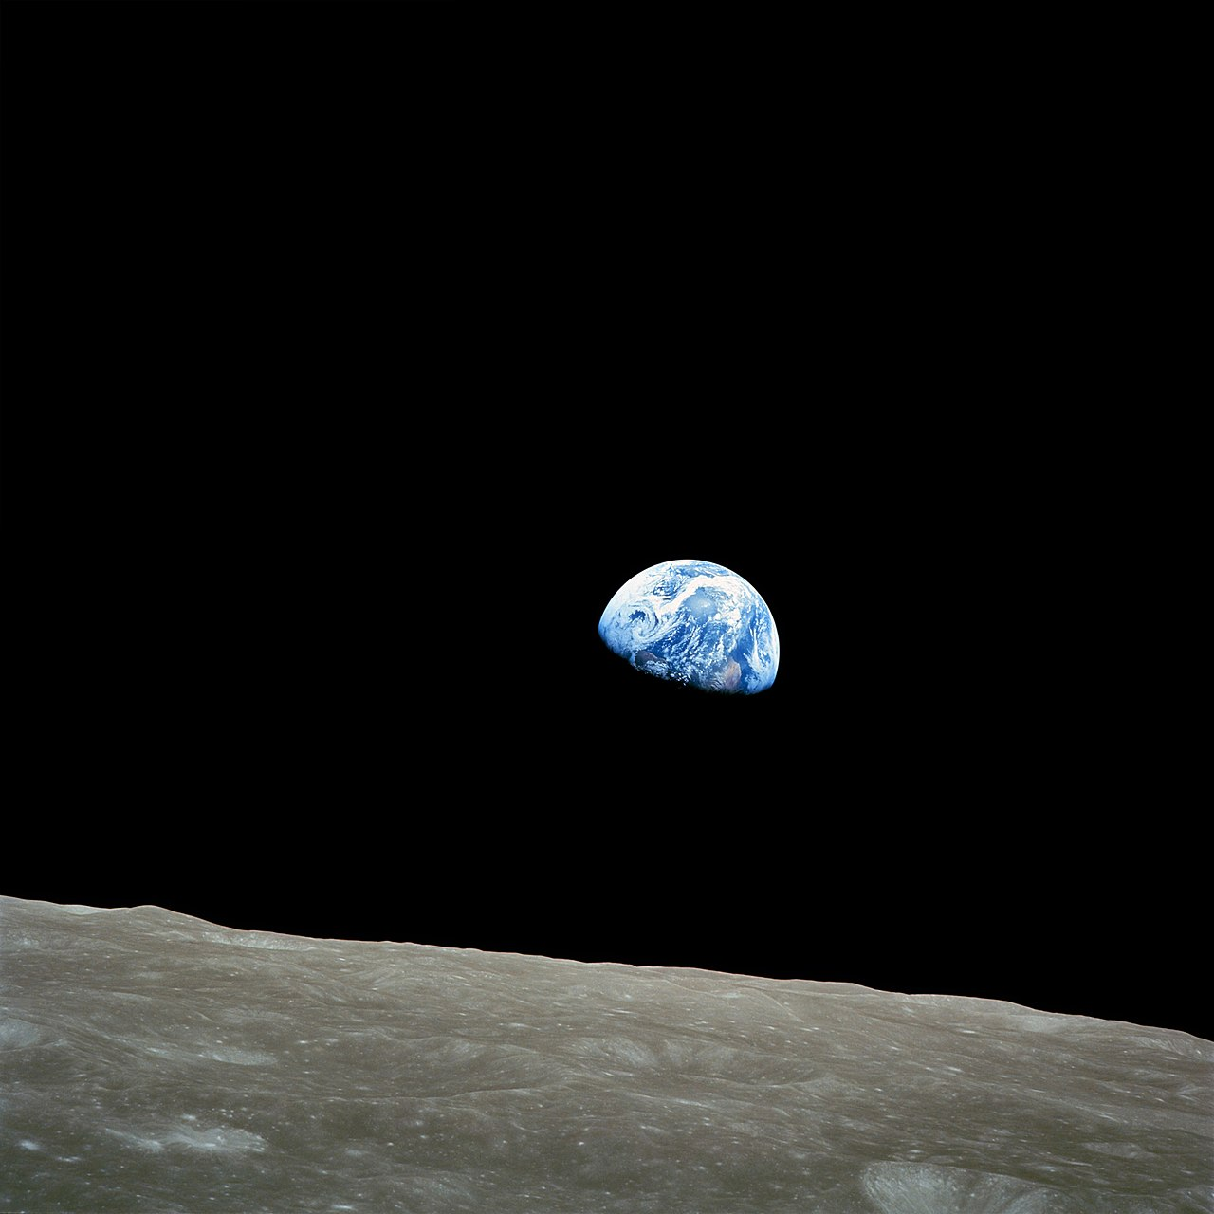

“Then Jesus said, “Did I not tell you that if you believe, you will see the glory of God?”” John 11:40 (New International)

[Blank]

Bring your emotions and hurt to Jesus.

“Jesus said to her, “I am the resurrection and the life. The one who believes in me will live, even though they die; and whoever lives by believing in me will never die. Do you believe this?”” John 11:25-26 (New International)

[Blank]

“Jesus wept.” John 11:35 (New International)

“So they took away the stone. Then Jesus looked up and said, “Father, I thank you that you have heard me. I knew that you always hear me, but I said this for the benefit of the people standing here, that they may believe that you sent me.”” John 11:41-42 (New International)

[Blank]

Keep going and keep trusting.

[Blank]

Lift your eyes up.

“Not only so, but we also glory in our sufferings, because we know that suffering produces perseverance; perseverance, character; and character, hope.” Romans 5:3-4 (New International)

[Blank]

“In his days may the righteous flourish and prosperity abound till the moon is no more.” Psalms 72:7 (New International)

[Blank]

“Therefore my heart is glad and my tongue rejoices; my body also will rest secure, because you will not abandon me to the realm of the dead, nor will you let your faithful one see decay. You make known to me the path of life; you will fill me with joy in your presence, with eternal pleasures at your right hand.” Psalms 16:9-11 (New International)

[Blank]

