Crave
“Community Building”
Bill Balbach, Lead Pastor September 12, 2021

[9/11 Graphic]

God hardwired us for relationships.

The Lord God said, “It is not good for the man to be alone. I will make a helper suitable for him.” Genesis 2:18 (New International)

[Blank]

Who we surround ourselves with matters.

“Walk with the wise and become wise, for a companion of fools suffers harm.” Proverbs 13:20 (New International)

[Blank]

“Do not be misled: “Bad company corrupts good character.”” 1 Corinthians 15:33 (New International)

We need to have an understanding of the relationship cycle.

[Relational Graphic 1]
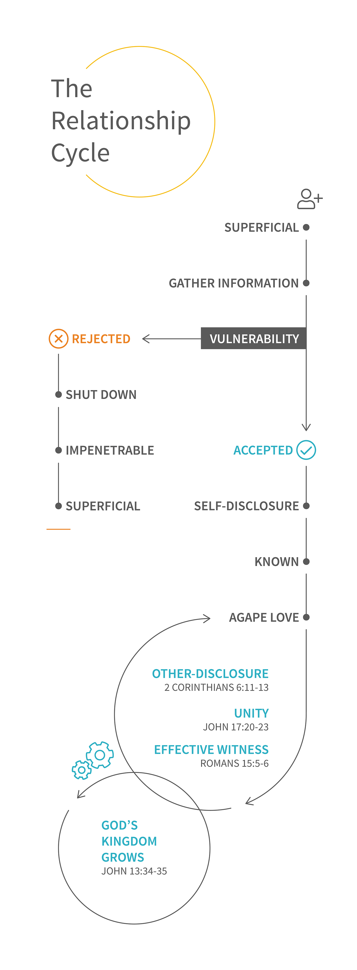

[Relational Graphic 2]
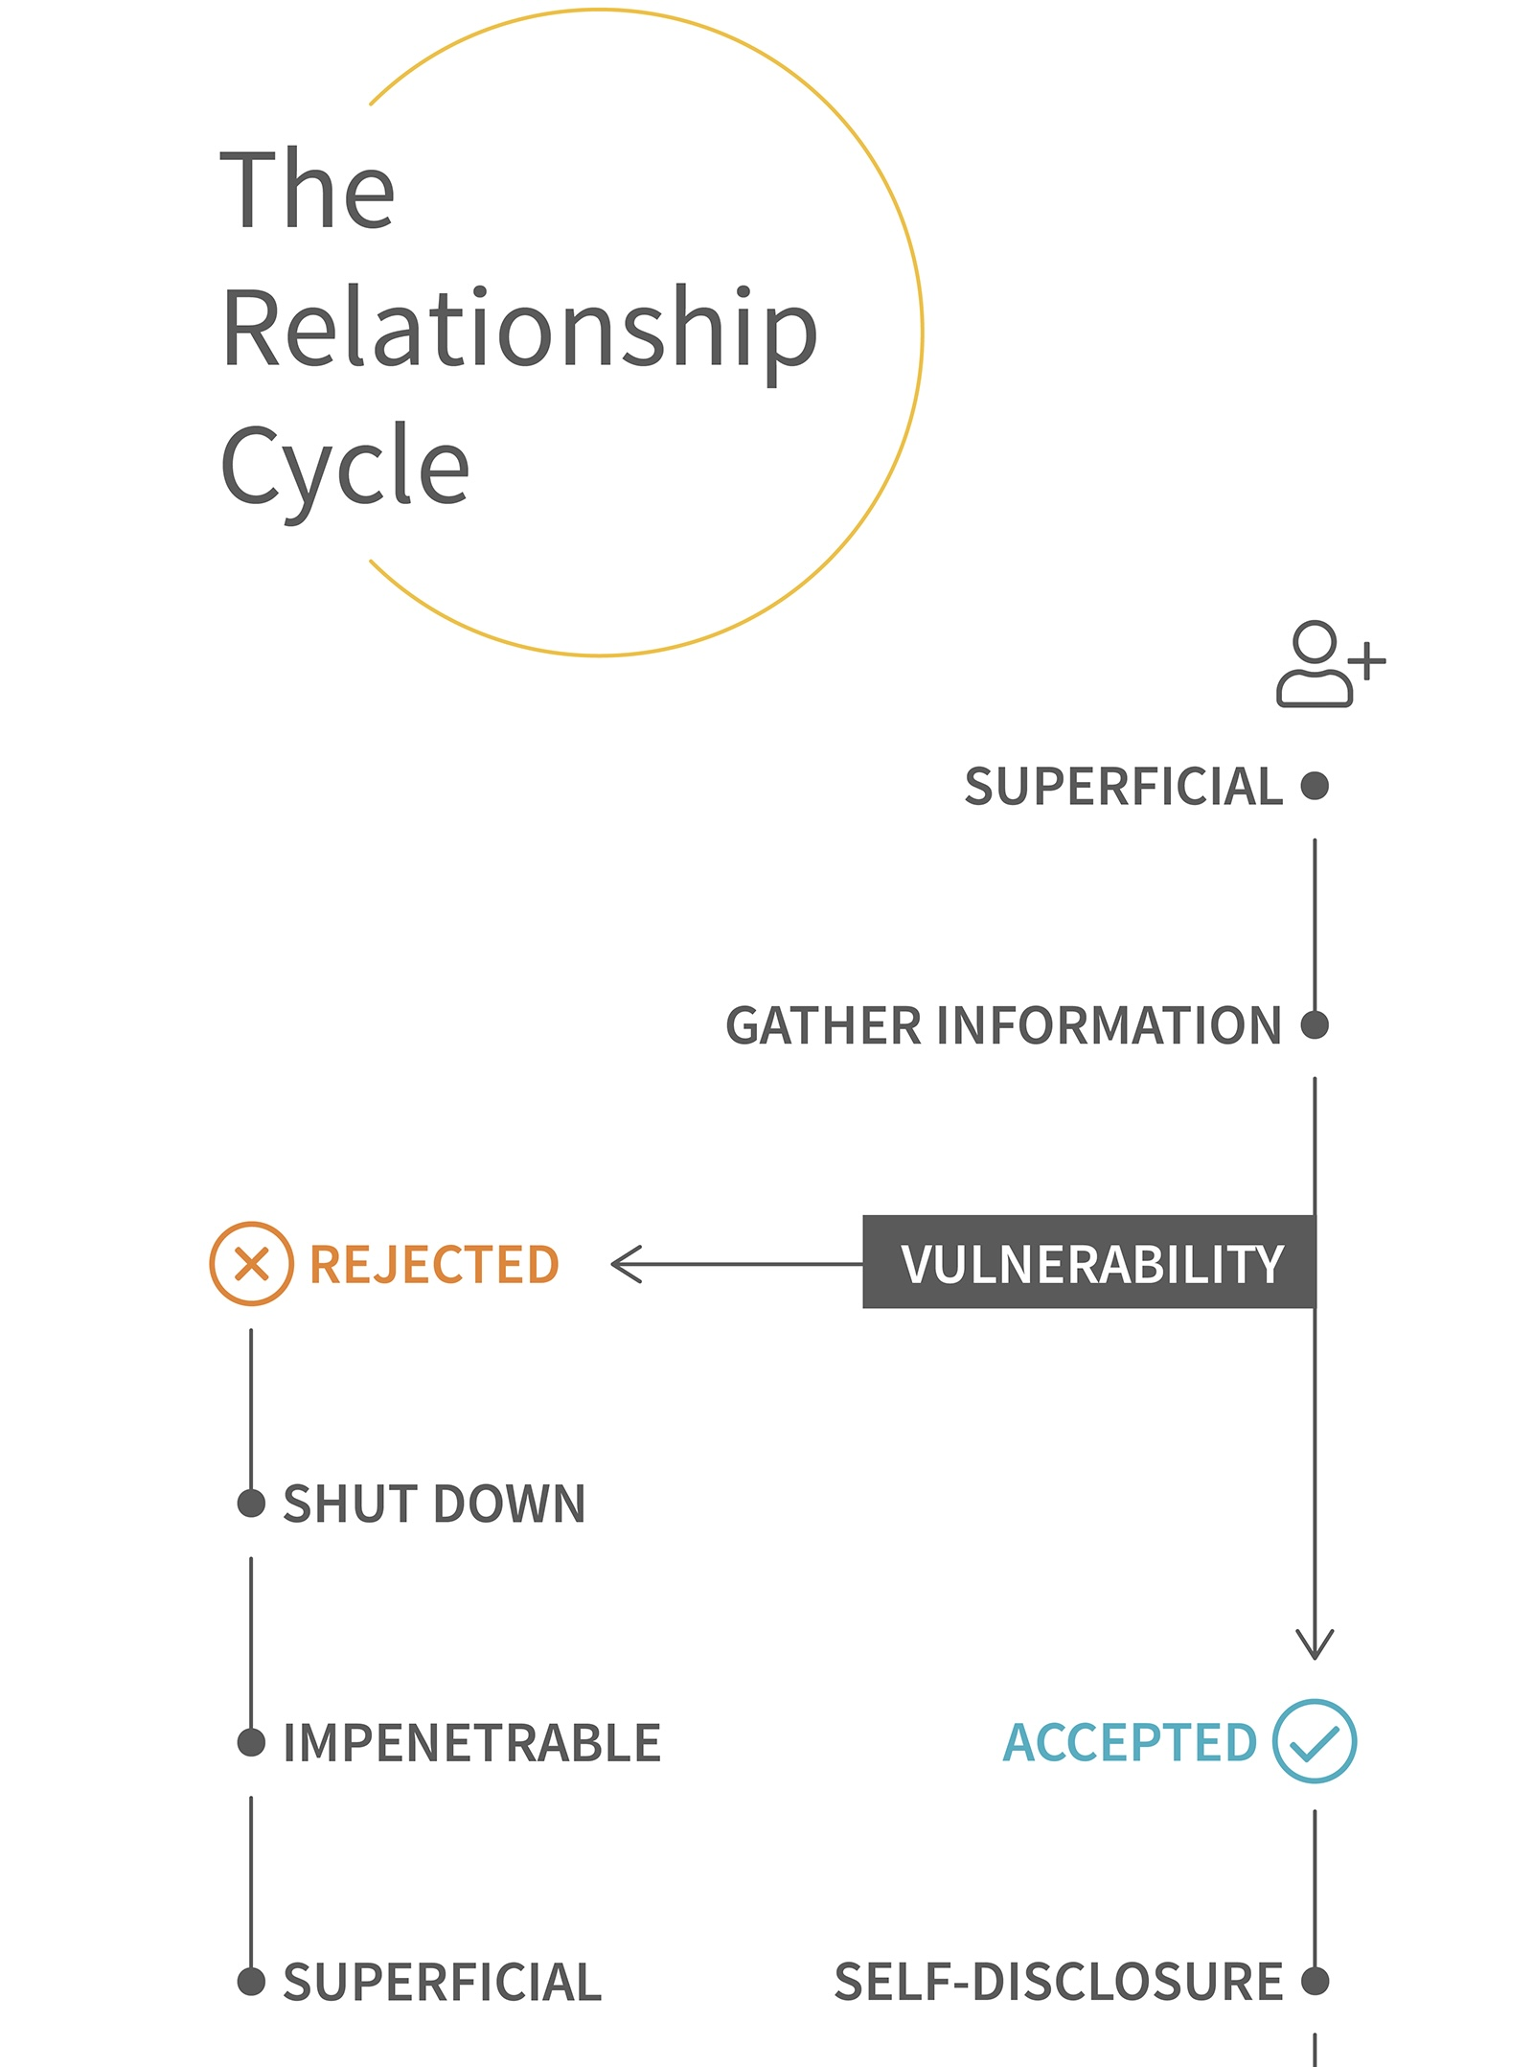

[Relational Graphic 3]
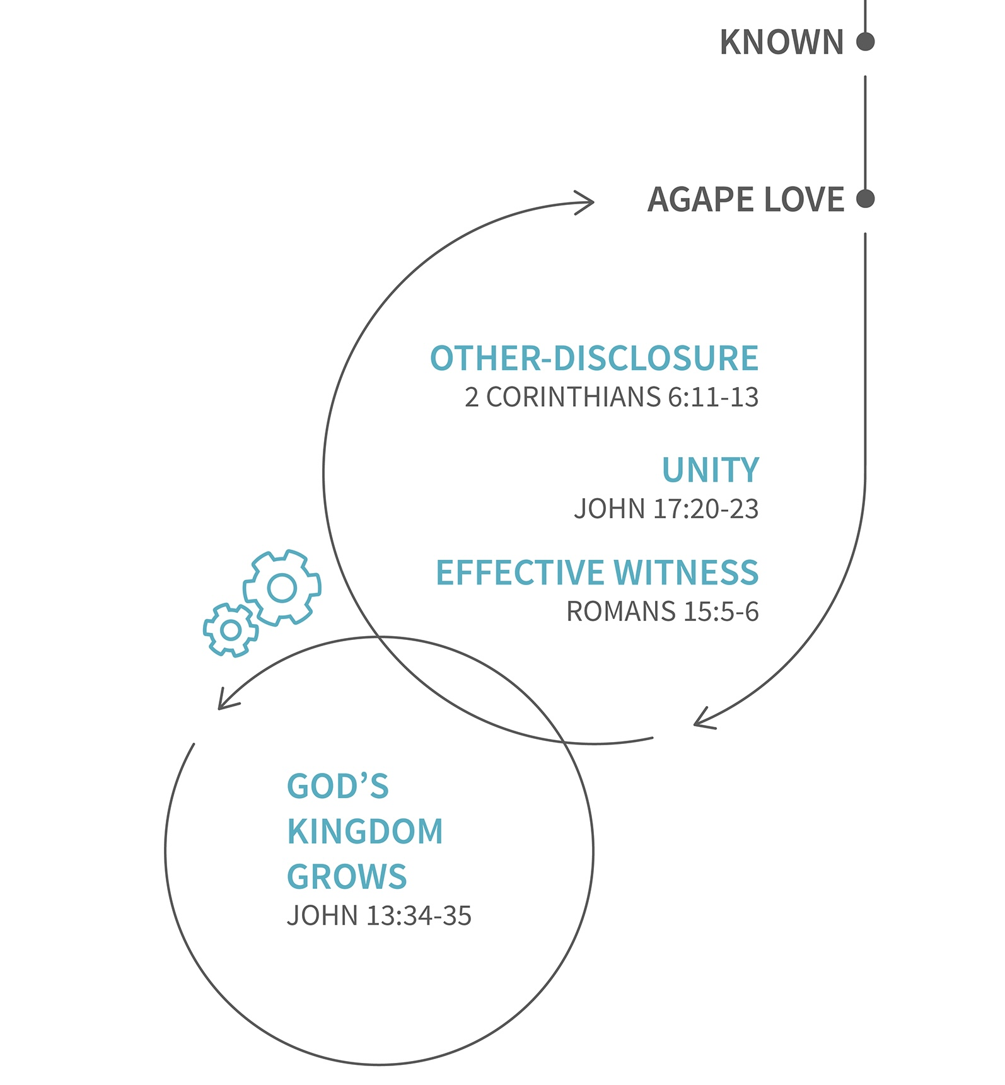

How we do community matters.

“They devoted themselves to the apostles’ teaching and to fellowship, to the breaking of bread and to prayer. Everyone was filled with awe at the many wonders and signs performed by the apostles. All the believers were together and had everything in common. They sold property and possessions to give to anyone who had need. Every day they continued to meet together in the temple courts. They broke bread in their homes and ate together with glad and sincere hearts, praising God and enjoying the favor of all the people. And the Lord added to their number daily those who were being saved.” Acts 2:42-47 (New International)

[Blank]

In community, we have an obligation to each other.

“And let us consider how we may spur one another on toward love and good deeds, not giving up meeting together, as some are in the habit of doing, but encouraging one another—and all the more as you see the Day approaching.” Hebrews 10:24-25 (New International)

[Blank]

