A Word From Jesus
“You Must Change and Become Like Little Children”
Steve Hammer, Lead Pastor September 6, 2020

(Blank)

At that time the followers came to Jesus and asked, “Who is greatest in the kingdom of heaven?” ²Jesus called a little child to him and stood the child before his followers. ³Then he said, “I tell you the truth, you must change and become like little children. Otherwise, you will never enter the kingdom of heaven. ⁴The greatest person in the kingdom of heaven is the one who makes himself humble like this child. ⁵“Whoever accepts a child in my name accepts me. ⁶If one of these little children believes in me, and someone causes that child to sin, it would be better for that person to have a large stone tied around the neck and be drowned in the sea. Matthew 18:1-6 (New Century)

(Blank)

(photo here)

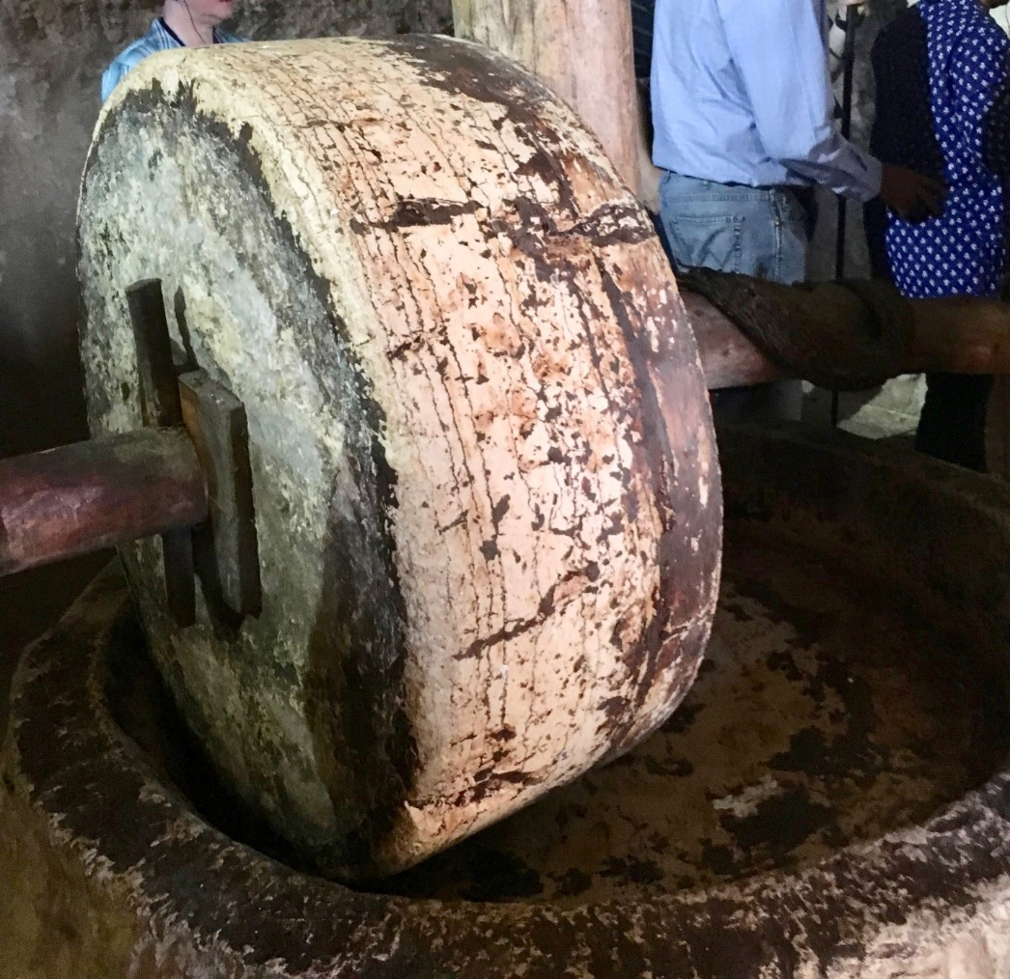

At that time the followers came to Jesus and asked, “Who is greatest in the kingdom of heaven?” ²Jesus called a little child to him and stood the child before his followers. ³Then he said, “I tell you the truth, you must change and become like little children. Otherwise, you will never enter the kingdom of heaven. ⁴The greatest person in the kingdom of heaven is the one who makes himself humble like this child. Matthew 18:1-4 (New Century)

A Childlike Humility

People who think they are better than others will be made humble. But people who humble themselves will be made great. Matthew 23:12 (Easy to Read)

In whatever you do, don’t let selfishness or pride be your guide. Be humble, and honor others more than yourselves. Philippians 2:3 (Easy to Read)

So humble yourselves under the mighty power of God, and at the right time he will lift you up in honor. 1 Peter 5:6 (New Living)

(Blank)

A Childlike Teachable Spirit

Like newborn babies, you must crave pure spiritual milk so that you will grow into a full experience of salvation. Cry out for this nourishment, ³ now that you have had a taste of the Lord’s kindness. 1 Peter 2:2-3 (New Living)

(Blank)

A Childlike Faith

- It is simple.

- It is trusting.

(Blank)

Trust the Lord completely, and don’t depend on your own knowledge. ⁶ With every step you take, think about what he wants, and he will help you go the right way. ⁷ Don’t trust in your own wisdom, but fear and respect the Lord and stay away from evil. Proverbs 3:5-7 (Easy to Read)

A Childlike Wonder

Blessed be the Lord God, the God of Israel, Who alone works wonders. ¹⁹And blessed be His glorious name forever; And may the whole earth be filled with His glory. Amen, and Amen. Psalm 72:18-19 (New American Standard)

(Blank)

