Love The Burgh
We Love You!
Steve Hammer, Lead Pastor June 8 & 9, 2019

(blank)
Announce Thursday services and Haggards:

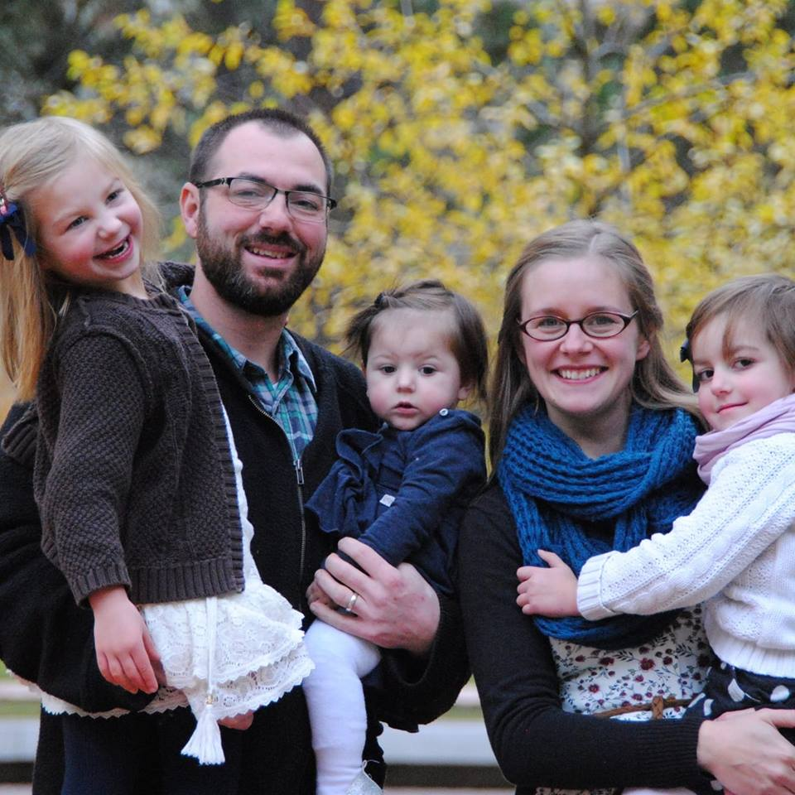

Can We caption this: Coming in August: The Haggard Family, Missionaries In Residence and Temporary Impact Staff
Don’t know if you want to be this specific: From Left to Right, Annaliese, Kenny, Tessa, Heather and Faith

(blank)

We Love You Too Much To Let You Stay Immature!

You have been believers so long now that you ought to be teaching others. Instead, you need someone to teach you again the basic things about God’s word. You are like babies who need milk and cannot eat solid food. For someone who lives on milk is still an infant and doesn’t know how to do what is right. Solid food is for those who are mature, who through training have the skill to recognize the difference between right and wrong. Hebrews 5:12-14 (New Living)

(blank)

We Love You Too Much To Let You Coast!

Reasons people coast:

(blank)

The opposite of coasting… Moving forward intentionally!

Spend your time and energy in the exercise of keeping spiritually fit. Bodily exercise is all right, but spiritual exercise is much more important and is a tonic for all you do. So exercise yourself spiritually, and practice being a better Christian because that will help you not only now in this life, but in the next life too. 1 Timothy 4:7b-8 (Living)

Be Intentional—Figure out your next step and take it!

Pursue God, Unleash Compassion, Build Community

(blank)

Don’t just pretend to love others. Really love them…. Never be lazy, but work hard and serve the Lord enthusiastically…When God’s people are in need, be ready to help them. Romans 12:9a, 11, 13a (New Living)

We Love You Too Much To Let You Stay Lost!

(blank)

Try to live in peace with everyone. And try to keep your lives free from sin. Anyone whose life is not holy will never see the Lord. Be careful that no one fails to get God’s grace. Hebrews 12:14-15a (Easy To Read)

(blank)

We want Impact to be a hard place to get to hell from.

There are 2 ways to keep your lives free from sin:

- Never sin.

Everyone has sinned and fallen short of God’s glorious standard Romans 3:23 (New Century)

If we say we have no sin, we are fooling ourselves, and the truth is not in us. 1 John 1:8 (New Century)

- Receive forgiveness.

If we say we have no sin, we are fooling ourselves, and the truth is not in us. But if we confess our sins, he will forgive our sins, because we can trust God to do what is right. He will cleanse us from all the wrongs we have done. 1 John 1:8-9 (New Century)

(blank)

Now, don’t wait any longer. Get up, be baptized and wash away your sins, trusting in Jesus to save you.’ Acts 22:16 (Easy To Read)

(blank)

